Chapter 8 - The Discrete Fourier Transform

Any discrete(and continuous) signal can be represented as the sum of properly chosen sinusoidal waves. - Pierre Simon de Laplace(1749 - 1827)

Family of Fourier Transform
Fourier Transform - for Aperiodic-Continuous signals
Fourier Series - for Periodic-Continuous signals
Discrete Time Fourier Transform - for Aperoidic-Discrete signals
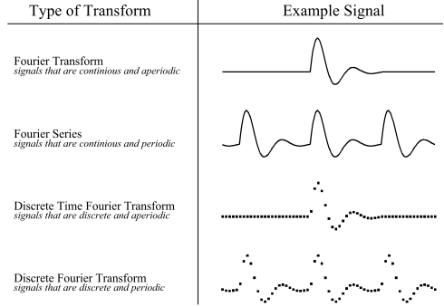
Discrete Fourier Transform - for Periodic-Discrete signals

All signals extend to positive and negative infinity, finite data will be made to look like they're infinite by adding copies(periodic) or zero values(aperiodic) to the ends.
To synthesize an aperiodic signal, you need an infinite number of sinusoids.

Because a computer can't work with infinity or continuity, the only option viable for Computers is the DFT (Discrete Fourier Transform)

Each of the four Fourier Transforms has a real and a complex version.

A transform is a function that allows multiple values for input and output, e.g. convert 100 input samples into 200 output samples or convert discrete into continuous data.

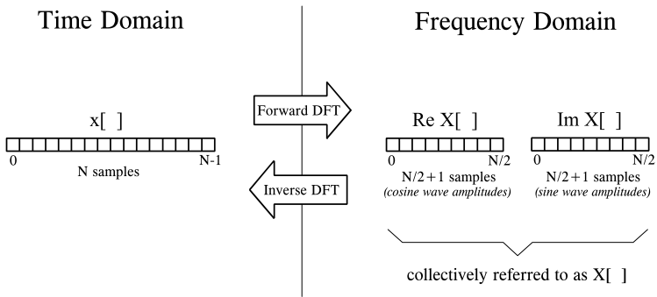
Notation and Format of the Real DFT
Input Signal:
Time Domain x[]
N points (time domain bcs data are regularly taken over time),
goes from x[0] to x[N - 1]
Output:
Frequency Domain
Real part Re X[], N/2 + 1 points, goes from ReX[0] to ReX[N/2]
Imaginary part Im X[], N/2 + 1 points, goes from ImX[0] to ImX[N/2]
Re X[] contains the amplitudes of the cosine waves(scaled)
Im X[] contains the amplitudes of the sine waves(scaled)

The frequency domain contains the exact same data as the time domain, but in a different form. If you know one, you can calculate the other.
time domain -> frequency domain: forward DFT, decomposition, analysis
frequency domain -> time doamin: inverse DFT, synthesis

N(number of samples) is typically 2^^k(a power of two) and between 32 and 4096.

Generally, you chosse a lowercase letter for time domain and an uppercase letter for frequency domain.

The Frequency Domain's Independent Variable
Example x[] 128 samples, Re X[] 65 samples
the horizontal axis of the frequency domain can be referred to in three different ways:
labeled from 0 to N/2 (corresponding to the sample index)
ReX[k] to ReX[k]with k from 0 to 64
labeled as a fraction of the sampling rate N( from 0 to 0.5):
ReX[f] with f from 0 to 0.5
f = k/N
labeled as fraction of sample rate N * 2 * Pi
ReX[w] with w from 0 to Pi
w = f * 2 * Pi
w : natural frequency, unit[radians]
used to make equations shorter, e.g. k: c[n] = cos(2Pi*k*n/N) = cos(2Pi*f*n) = cos(w*n)
labeled specifically for one application
not suitable for general DFT equations

DFT Basis Functions
refers to the sine and cosine waves with unity amplitude.
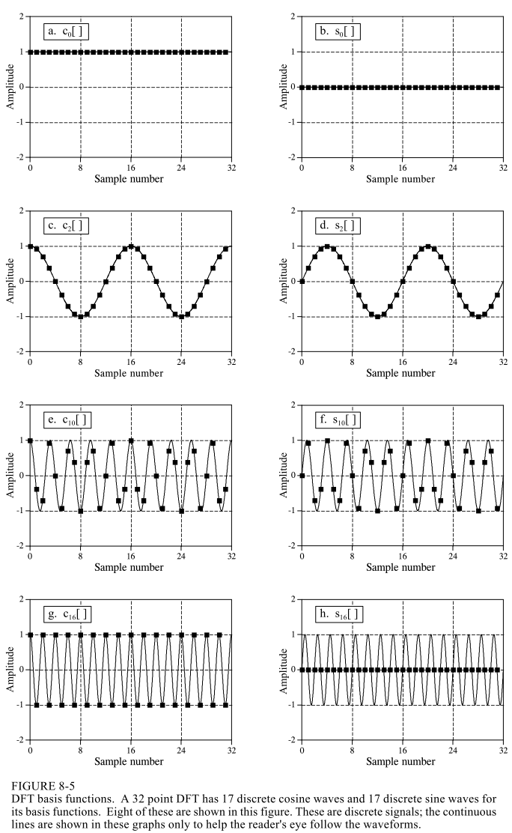
A 32 points DFT has 17 discrete cosine waves and 17 discrete sine waves for its basis functions.
DC Offset: The average value of all the points in the time domain signal.
As there are N samples entering the DFT and N + 2 samples exiting, the values at Im X[0] and Im X[N/2] have a value of zero: They contain no information.

Synthesis, Calculating the Inverse DFT
synthesis equation:
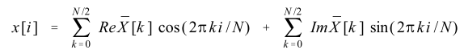
i is the position in the time domain,
k is the frequency
The arrays Im X[i] and Re X[i] are slightly different from the frequency domain: The amplitudes are scaled back to the original form.
conversion:
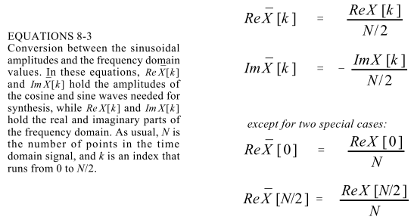
The scaling difference occurs because of Spectral density.
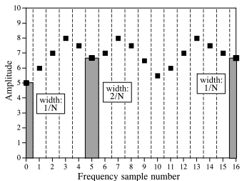
Spectral density describes how much signal(amplitude) is present per unit of bandwith. To convert the sinusoidal amplitudes into a spectral density, divide each amplitude by the bandwith represented by each amplitude.
The bandwith is defined by drawing dividing lines between the samples: This way, each sample has a bandwith of 2/N, except the samples one the ends, which have a bandwith of 1/N.

The negation of the imaginary part is solely to make the real DFT consistent with the complex DFT.

Analysis, Calculating the DFT
The DFT can be calculated in three completely different ways:
simultaneous equations:
useful for understanding the DFT, but too inefficient
correlation:
based on detecting a known waveform in another signal
Fast Fourier Transform (FFT):
hundreds of times faster than the other methods
correlation is the preferred technique if the DFT has less than ca. 32 points, otherwise the FFT is used.

DFT by Simultaneous Equations
Basic algebra to find the N values of the frequency domain(2 values are known to be 0):
to solve for N unknowns, write N linearly independent equations.
The equations are as followed:
The sum of the samples at position i of each sinusoid must be equal to the sample in the time domain at position i.
It can be solved by using established methods for simultaneous equations, e.g. the Gauss Elimination.
This method shows why it is possible to decompose a signal into sinusoids, how many sinusoids are needed, and that the basic functions must be linearly independent.
DFT by Correlation
This is the standard way of calculating the DFT.
The concept of correlation(Chapter 7) goes like this:
to detect a known waveform in another signal, multiply the two signals and add the points in the resulting signal. The single number that results from this is a measure of how similar the two signals are.
Now, e.g. for a 64 point signal, you do this process for each possible wave. There are 33 sinus and 33 cosinus waves to check.
E.g. to get the value/amplitude of Im X[3], you create a 64 point signal that contains the sinus wave with frequency 3. Now, you multiply that signal with the input signal. If the sum of all the points is 32(half of the points), it's the same signal. However if the sum is 0, there's no correlation: The input signal doesn't contain that frequency. So the sum actually matches the scaled amplitude(amplitude* N / 2)

This procedure is formalized in the analysis equation, the mathematical way to calculate the frequency domain from the time domain:
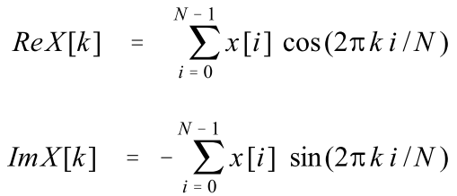

k runs from 0 to 32.

In words, each sample of the frequency domain is found by multiplying the time domain signal by the sine or cosine wave being looked for, and adding the resulting points. So you're basically correlating the input signal with each basic function.
All basis functions are orthogonal: They're completely uncorrelated with each other.
Duality
The symmetry between time and frequency domains is called duality:
they use the same mathematical approach, indeed the formulas are almost the same.
The complex DFT makes the equations for moving between the domains virtually identical.
This leads to many interesting properties:
a single point in the frequency domain corresponds to a sinusoid in the time domain; and a single point in the time domain corresponds to a sinusoid in the frequency domain.
convolution in the time domain corresponds to multiplication in the frequency domain; by duality, the reverse is also true.
Polar Notation
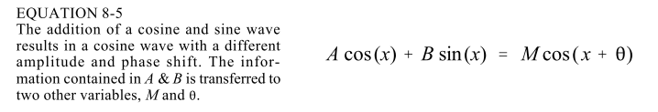
The sum of a sine and cosine wave with the same frequency is a cosine wave with a different amplitude and a phase shift.
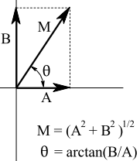
Instead of having the amplitudes A and B, you can have an amplitude M and a phase shift O to contain the same information. This is similar to representing a point with an angle and a length instead of x and y coordinates.

In polar notation, the array Mag X[] holds the amplitude of the cosine wave, while
Phase X[] holds the phase angle of the cosine wave.
The following equations convert the frequency domain between rectangular and polar notation:
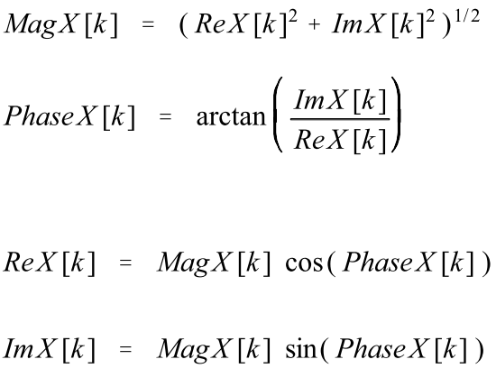

← Take care of divide by zero error! Best way is to make ReX[k] really small ; the shift is either -Pi/2 or +Pi/2.

A cosine wave is used because a cosine wave with frequency 0 can hold a value(the DC Offset) whereas a sine wave with frequency 0 only has values of 0.

For calculations, the rectangular notation is the best choice. The polar form is usually used by graphs as it's almost impossible for humans to understand the characteristics of a frequency domain signal by looking at the real and imaginary parts.

The Fast Fourier Transform
The Fast Fourier Transform is based on the complex DFT. It's calculating a complex DFT a lot times faster than in other ways.
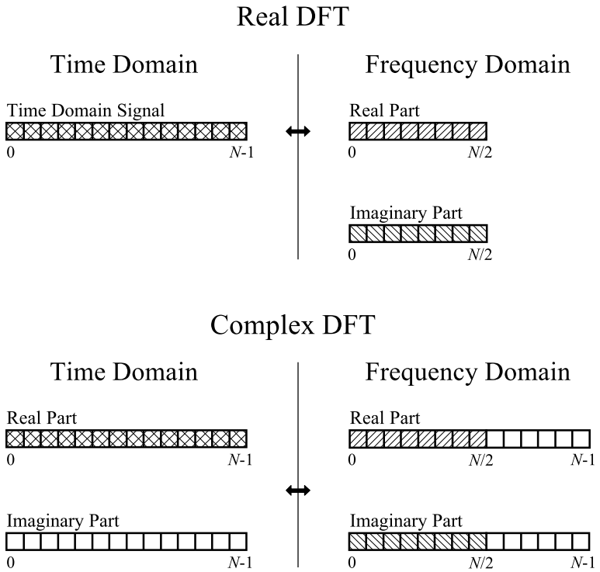
Comparison of Real and Complex DFT:

To do a Real DFT with a complex DFT, you need to format the real DFT data into and out of the complex DFT format. That is:
- Set all values in the Imaginary Part of the Time Domain to zero.
- The samples in the Frequency Domain for the Real and the Imaginary Part from 0 to N/2 correspond to the real DFT'S spectrum.
For the complex Inverse DFT, the values of the Frequency Domain have to be in the following format:
- Values for the Real and Imaginary Part from 0 to N/2 correspond to the real DFT's spectrum.
- Real Part:
  - Point N/2 + 1 is same as Point N/2 – 1, [N/2 + 2] = [N/2 – 2], …, [N-1] = [1]
- Imaginary Part:
  - Same basic pattern, but the sign is changed. That is:
  - [N/2 +1] = - [N/2 – 1], …, [N – 1] = - [1]
- Samples at 0 and N/2 do not have a matching partner.

If all values were set correctly, the Imaginary Part of the Time Domain should contain only zeros.

How the FFT works
In complex notation, the time and frequency domains each contain one signal made up of N complex points. Each of these complex points X[i] contains a real part Re X[i] and a imaginary part Im X[i].

The FFT operates by decomposing an N point time domain signal into N time domain signals each composed of a single point. Then, the N frequency spectra corresponding to these N time domain signals are calculated. Lastly, the N spectra are synthesized into a single frequency spectrum.
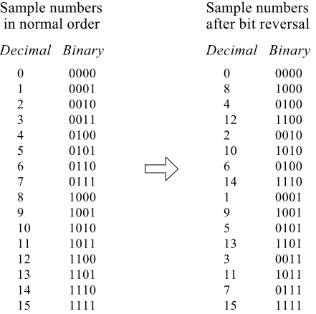
Example of the decomposition:
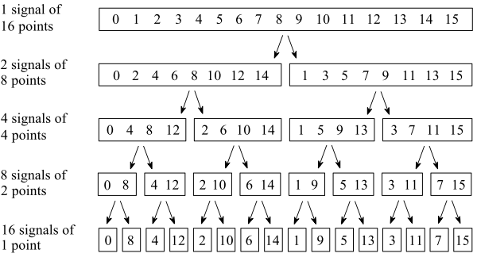
In the separate stages of the decomposition, the 16 point signal is broken into two 8 point signals, then four 4 point signals, and so on until there are N signals composed of a single point.
An Interlaced Decomposition is used each time a signal is broken in two: the signal is separated into its even and odd numbered samples. The Decomposition takes steps.

The decomposition is nothing more than reordering the samples in the signal. The rearrangement pattern is a bit reversal( as shown in the right picture). The idea is that the binary numbers are the reversal of each other, so e.g. sample 3(0011) is swapped with sample 12(1100), or sample 1(0001) is swapped with sample 8(1000). (This of course requires N = 2^{i})

The next step is calculating the frequency domain of the samples. As the frequency spectrum of a 1 point signal is equal to itself, nothing is required to do in this step.

In the last step, the N frequency spectra are combined in the exact reverse order that the time domain decomposition took place. Here, you have to go back one stage at a time, so 16 1-sample signals to 8 2-samples signals to 4 4-sample signals and so on. The last stage results in the output of the FFT.

